Siemens Siprotec As found (AF) and As left (AL) files comparison
- Save the setting files from the Device.
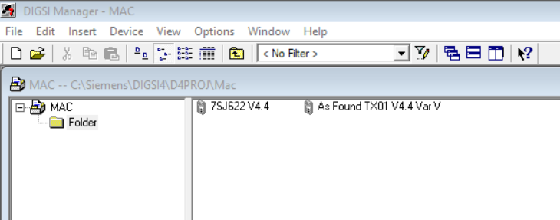
- After finishing tests, disconnect the relay.
- Reopen DIGSI4 and right-click of AF file to change the file name.
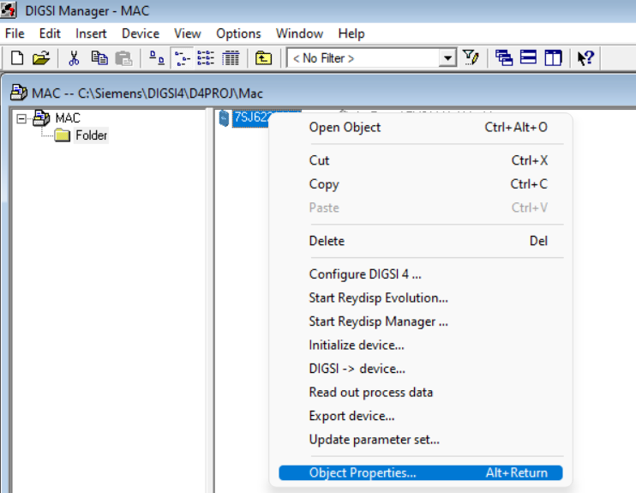

- Change the name and click okay.
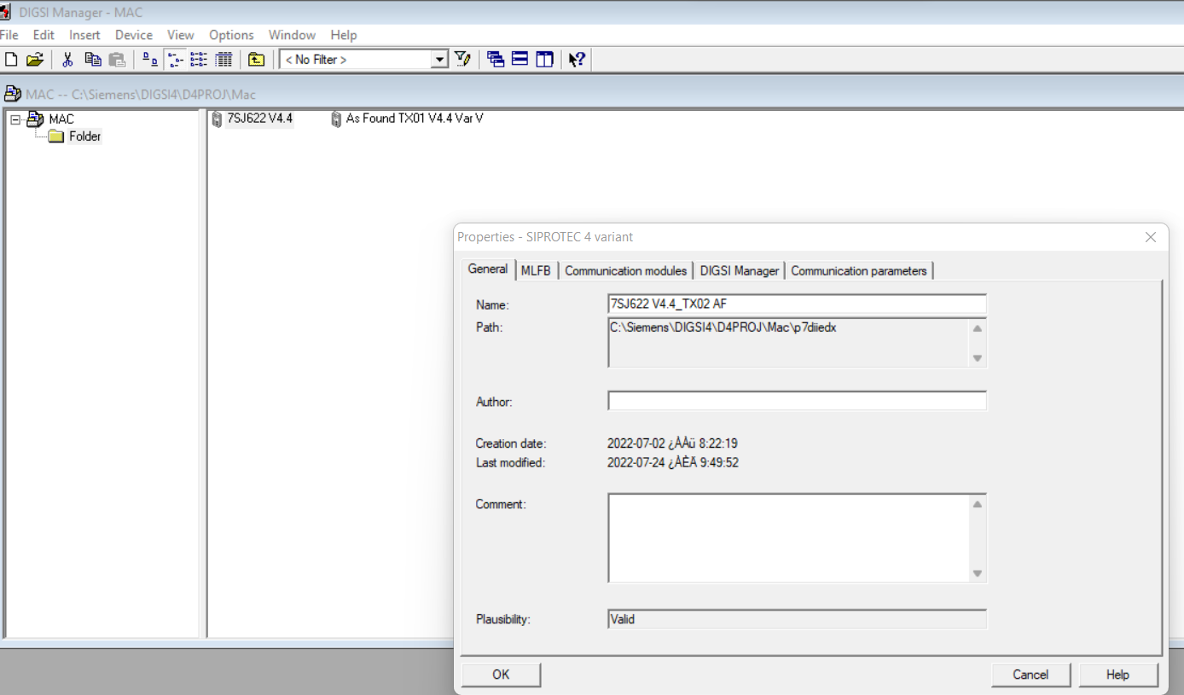

- Now the name is changed.
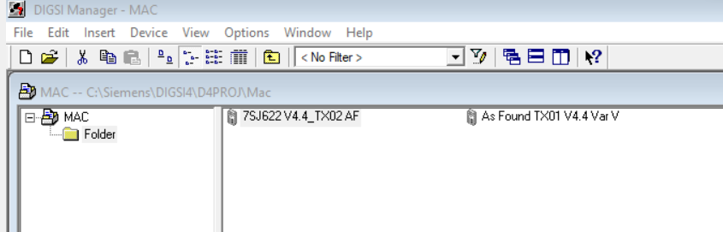

- Double-click the new file name and select Offline.
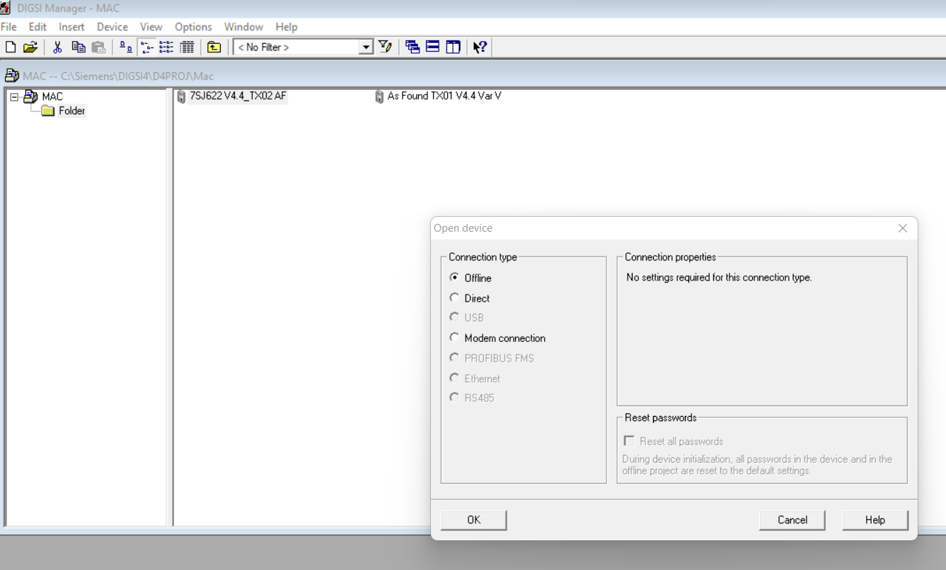
- Click Okay and open the window.
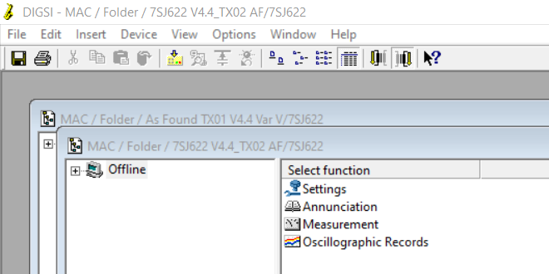

- Go to “Compare parameters….”

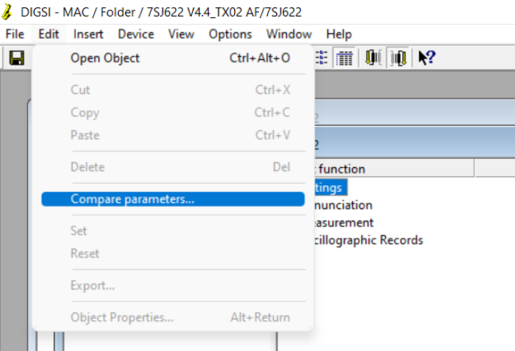

- Locate the file required to be compared.
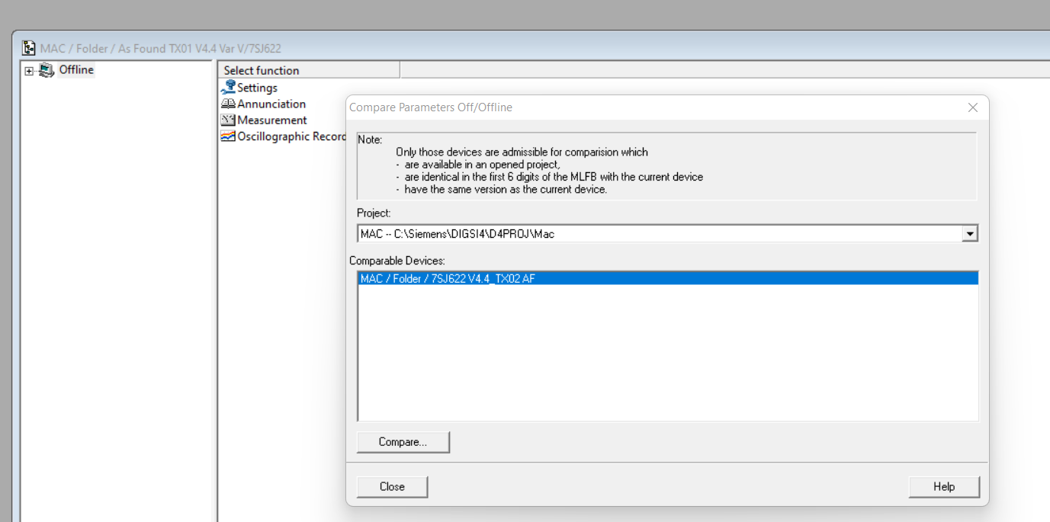

- Compare via pressing “Start” and print the results.
